FILIUS COMPUTER NETWORK
NETWORK PICTURE
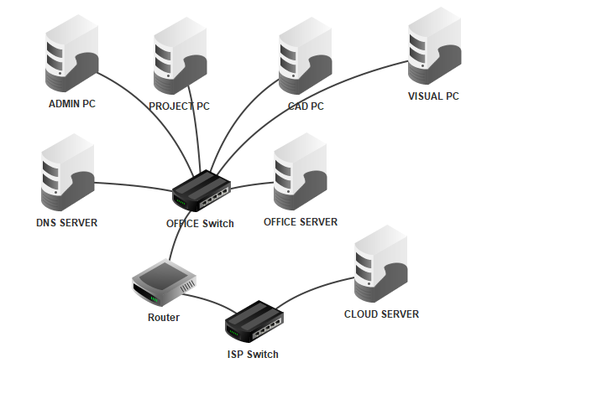 IP ADDRESSING TABLE

Device | IP address | Subnet mask | Default gateway | DNS server
Admin PC | 192.168.10.101 | 255.255.255.0 | 192.168.10.1 | 192.168.10.2
Project PC | 192.168.10.111 | 255.255.255.0 | 192.168.10.1 | 192.168.10.2
CAD PC | 192.168.10.121 | 255.255.255.0 | 192.168.10.1 | 192.168.10.2
Visual PC | 192.168.10.131 | 255.255.255.0 | 192.168.10.1 | 192.168.10.2
DNS Server | 192.168.10.2 | 255.255.255.0 | 192.168.10.1 | 192.168.10.2
Office Server | 192.168.10.10 | 255.255.255.0 | 192.168.10.1 | 192.168.10.2
Router — office interface | 192.168.10.1 | 255.255.255.0
Router — external interface | 203.0.113.1 | 255.255.255.0
Cloud Server | 203.0.113.10 | 255.255.255.0 | 203.0.113.1 | 192.168.10.2
IP ADDRESSING OF EACH
MY PART WAD TO ASSINGN IP ADDRESS THESE ARE THE IP ADDRESSES OF ALL WITH PICTURES .
ADMIN IP :
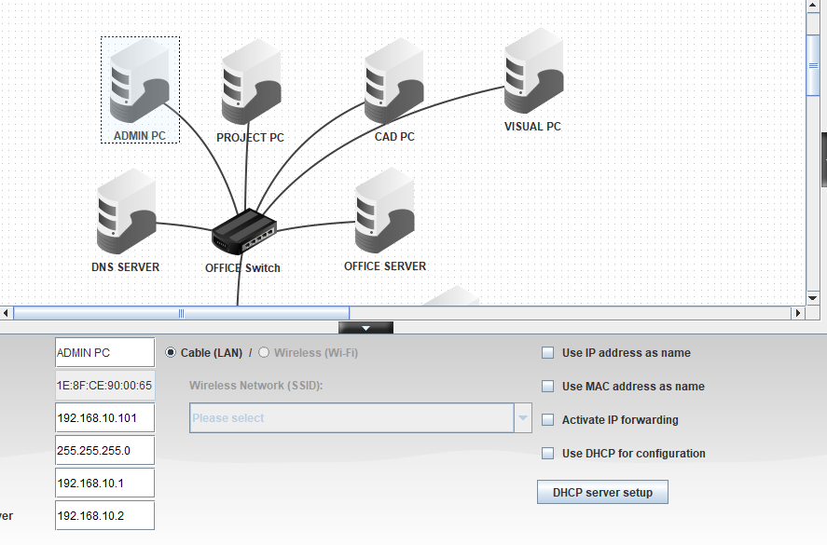
CAD IP :
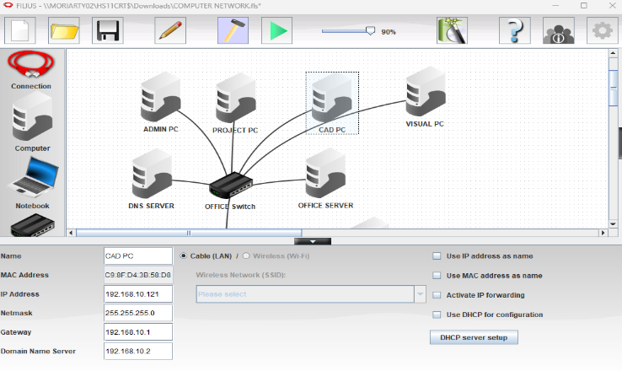
DNS IP :
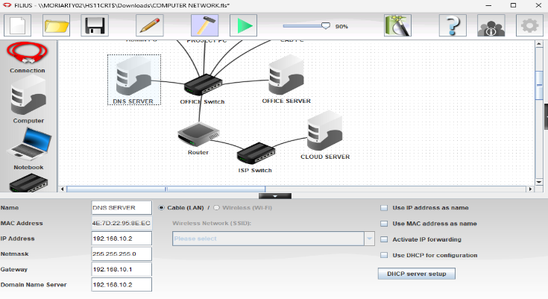
PROJECT IP :
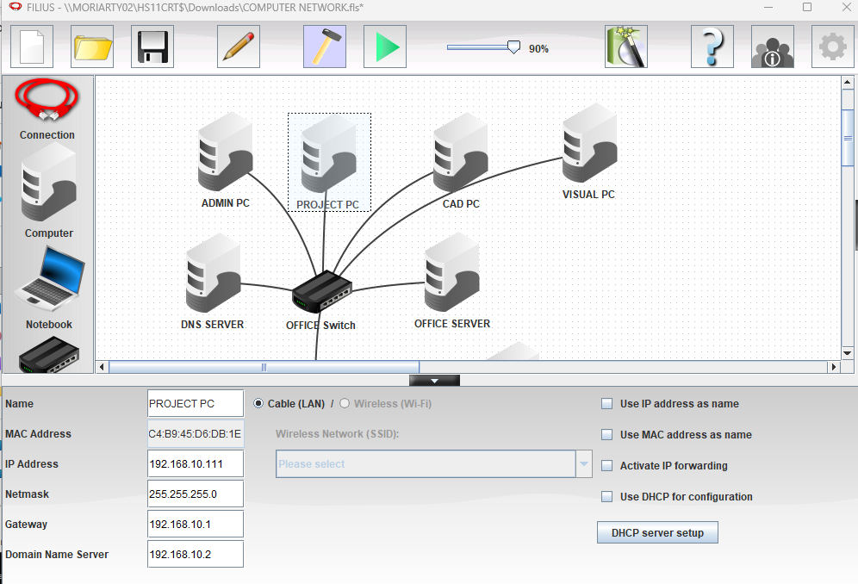
OFFICE IP :
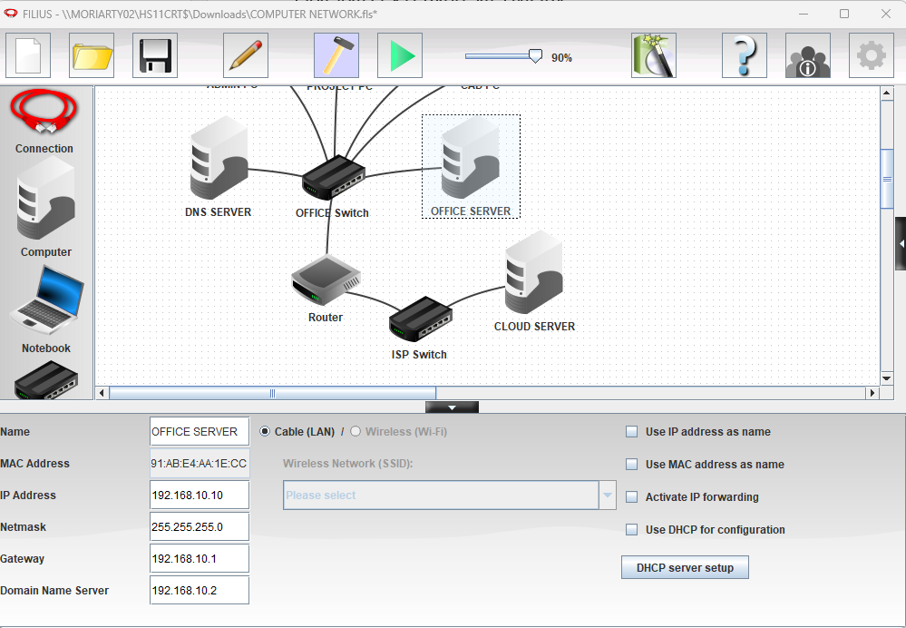
CLOUD IP :
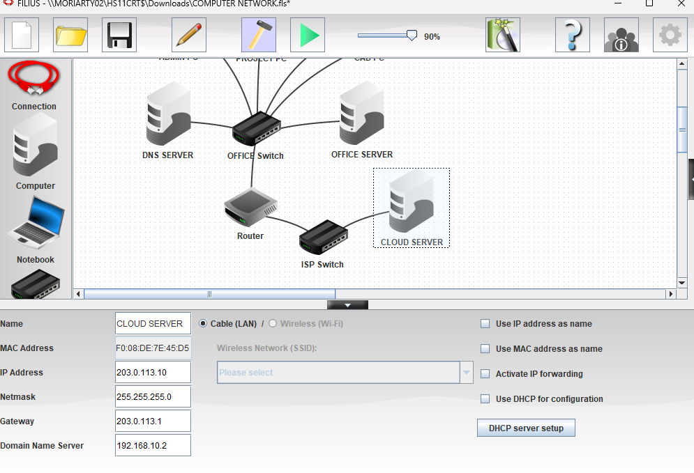
DNS RECORD

Website name | IP address
intranet.archstudio.local | 192.168.10.10
cloud.archstudio.example | 203.0.113.10

PROTOCOLS AND NETWORKING CONCEPTS
Protocol | explanation
IP | Provides logical addresses so packets can be sent to the correct device or network.
DNS | Finds the IP address associated with a website name.
HTTP | Lets a web browser request website content from a web server.
ICMP | Used by ping to test reachability and report network errors.
Ethernet | A common technology used to send data across a wired local area network.
TCP | Provides reliable, ordered delivery of data between applications.
Default gateway | The router interface a device uses to send traffic to other networks.

LAN AND EXTERNAL NETWORK
The LAN is the local network inside the office. It contains four office PCs, a DNS server and an office web server. These devices use addresses in the 192.168.10.0/24 network. The office switch connects local devices, while the router acts as the gateway to another network.
CLIENT SERVER MODEL
In the client-server model, a client requests a service and a server provides it. In this project, the CAD PC is a client when it uses a browser to request a web page. The Office Server hosts the internal company page, and the Cloud Server hosts the external cloud page. The DNS server helps the client find the correct server by translating a website name into an IP address.
TESTING RECORD

Test | Command | Actual result
Ping Admin PC | ping 192.168.10.101 | 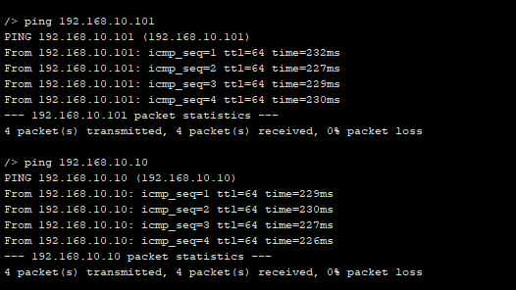
Ping Office Server | ping 192.168.10.10
Ping DNS Server | ping 192.168.10.2 | 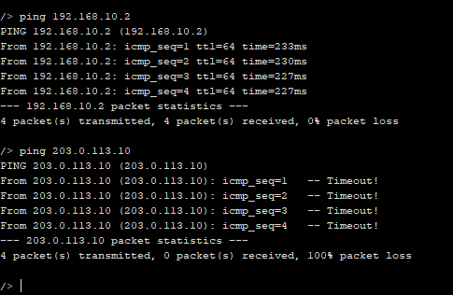
Ping Cloud Server | ping 203.0.113.10
Internal website | http://intranet.archstudio.local | 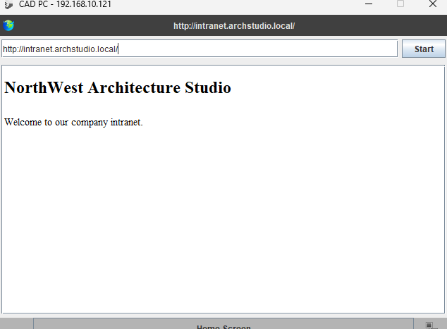
External website | http://cloud.archstudio.example | 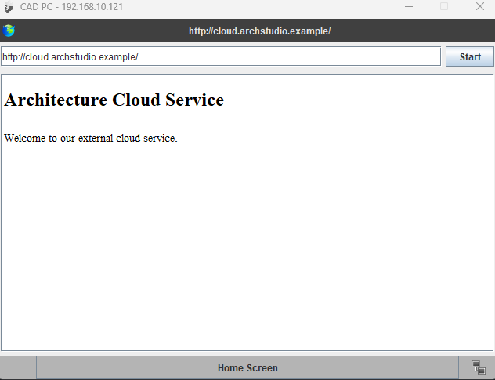

NETWORK TOPOLOGY
ROUTER INTERFACE
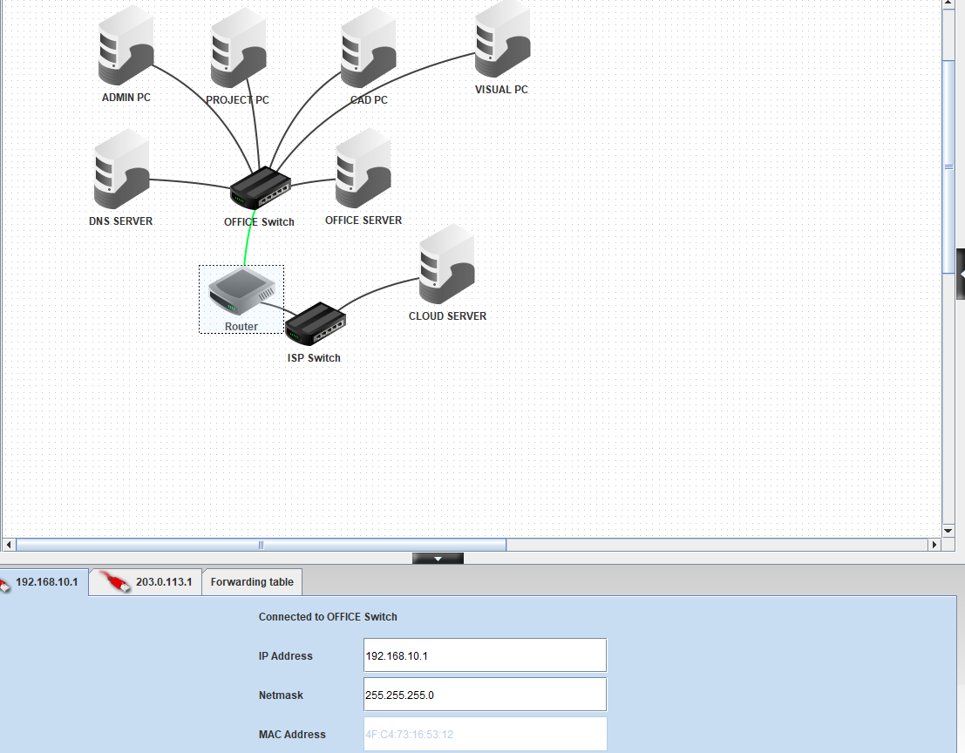
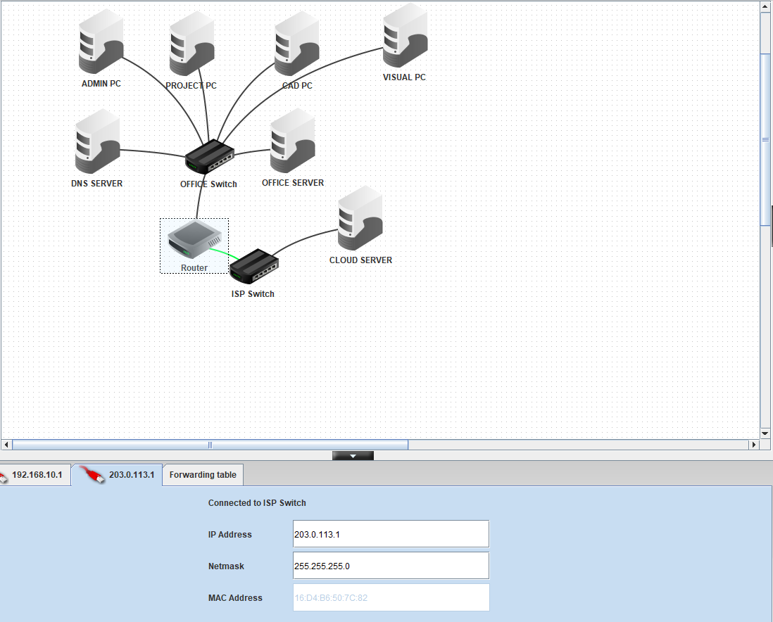

DNS
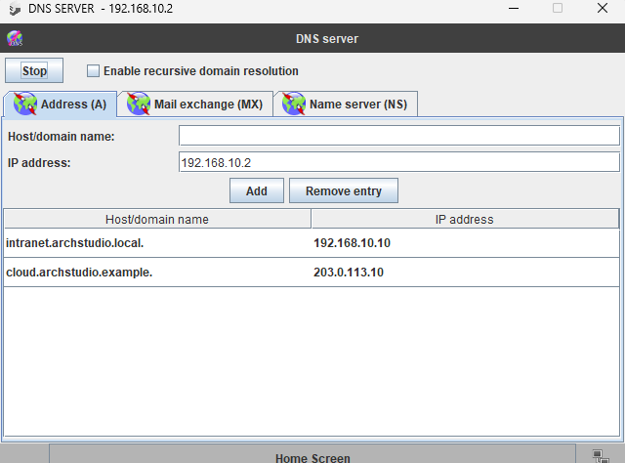

WEBSITE

PING TEST

